
CYBERSTER
Internship Program - Batch 2
NetSec Internship - Week 2 Task Report
Logical Infrastructure Design & Physical Media Deployment
Intern Name: | Muhammad Raza
Instructor Name: | Muhammad Huzaifa Riaz
Company: | CYBERSTER (Batch 2)
Task: | Logical Infrastructure Design & Physical Media Deployment
Date: | 4 July 2026

1. Logical Network Design (Objective 1)
The following topology was designed using Cisco Packet Tracer to simulate a hybrid enterprise environment containing both a Corporate Wired LAN and a Wireless Mobility Zone.

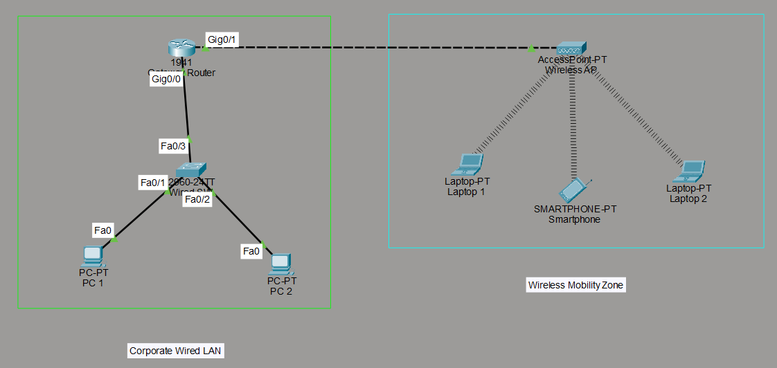
Figure 1: Complete logical topology showing active wired and wireless connections.

Design Overview
Zone | Description
Corporate Wired LAN | A Cisco 1941 Gateway Router connects to a 2960 Switch, providing hardwired FastEthernet access to two corporate desktop workstations.
Wireless Mobility Zone | The Gateway Router connects to a Wireless Access Point to bridge the logical networks, providing 2.4GHz wireless connectivity to two laptops and a smartphone.

Wireless Module Configuration
To enable wireless connectivity for the laptops in the mobility zone, the default FastEthernet modules had to be physically powered down and replaced with WPC300N 2.4GHz wireless network interface cards.

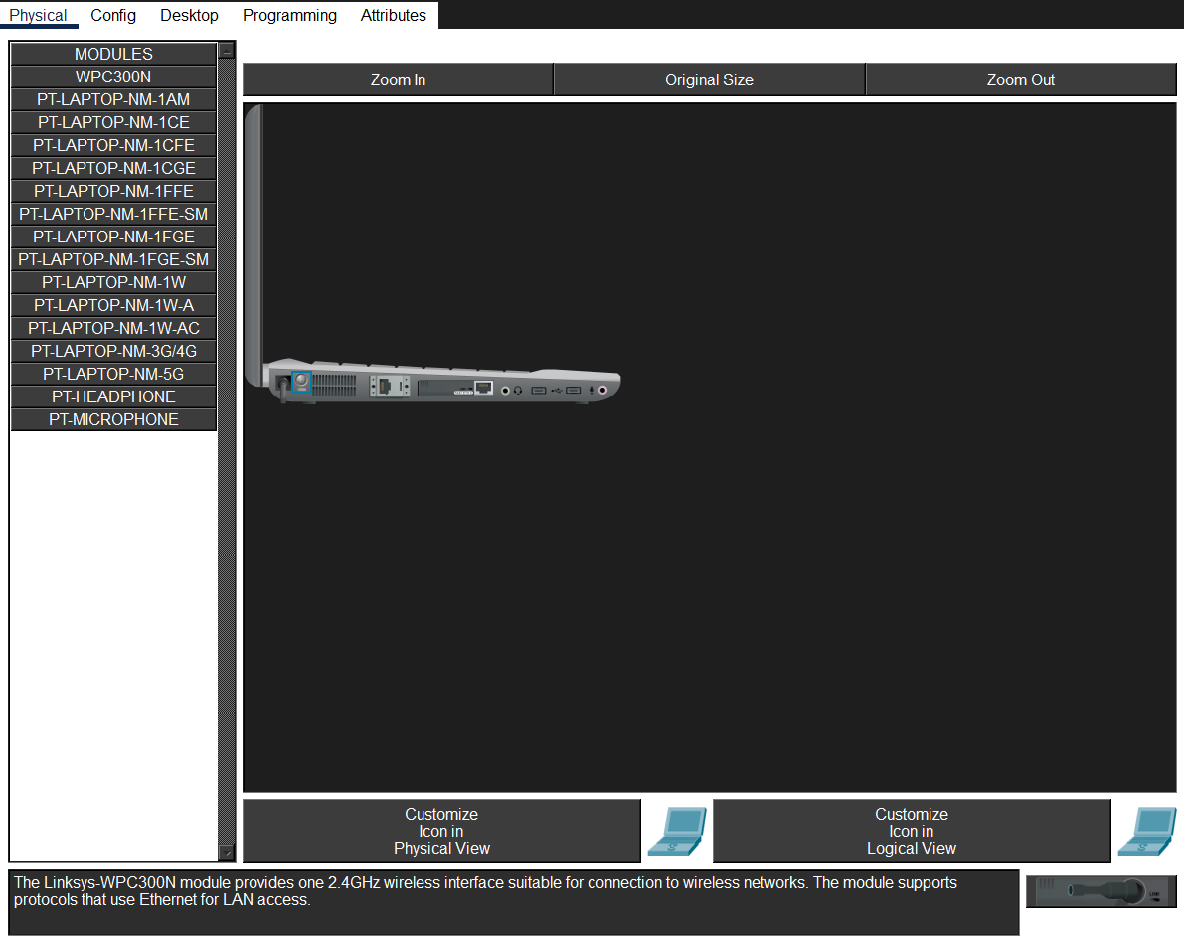
Figure 2: Default FastEthernet interface

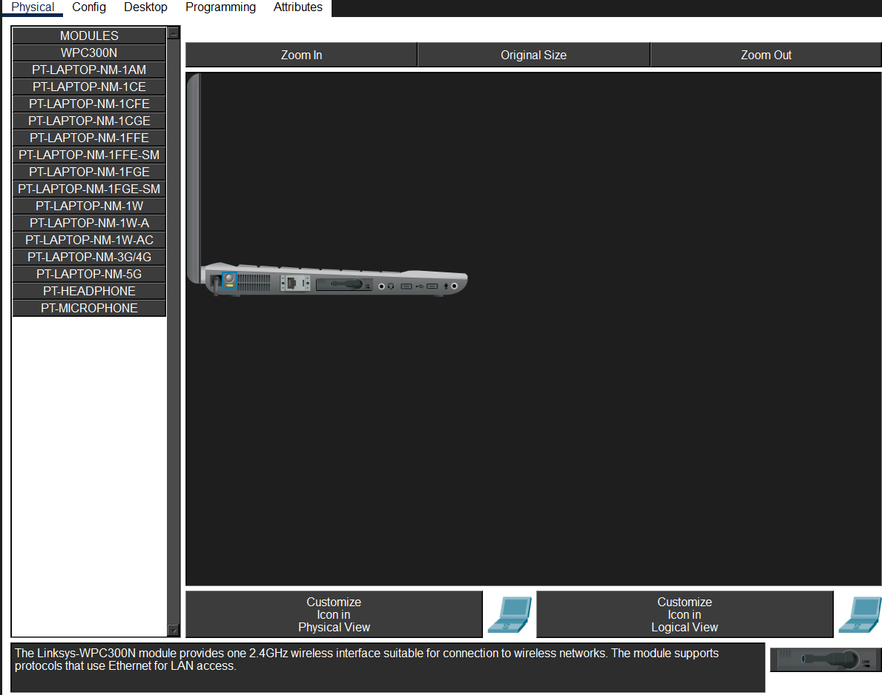

Figure 3: WPC300N wireless module installed

2. Physical Tools Inventory (Objective 2)
To deploy physical Layer 1 infrastructure, several specific hardware tools were utilized during the execution phase. Below is the inventory and purpose of each tool:

Tool | Purpose & Function | Photo
Cat5e / Cat6 Cable | The primary twisted-pair copper media used to transmit physical layer signals across the network. Supports up to 1 Gbps over 100 metres. | 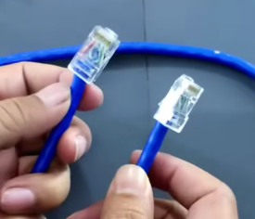
RJ-45 Connector | The 8-pin modular connector that terminates the copper cable and plugs directly into NICs and switch interfaces. | 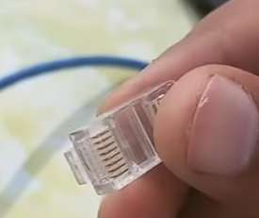
Wire Stripper | A specialized tool used to cleanly slice and remove the external PVC insulation jacket without scoring or damaging the inner copper wires. | 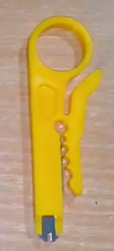
Crimping Tool | A heavy-duty hand tool that applies mechanical pressure to embed the RJ-45 gold-plated pins firmly into the inner copper conductors. | 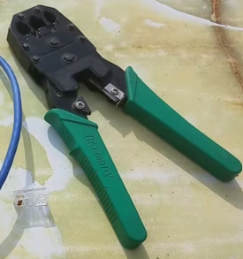
LAN Cable Tester | An electronic diagnostic tool used to verify pin-to-pin continuity and test for shorts or split pairs across all 8 internal pins. | 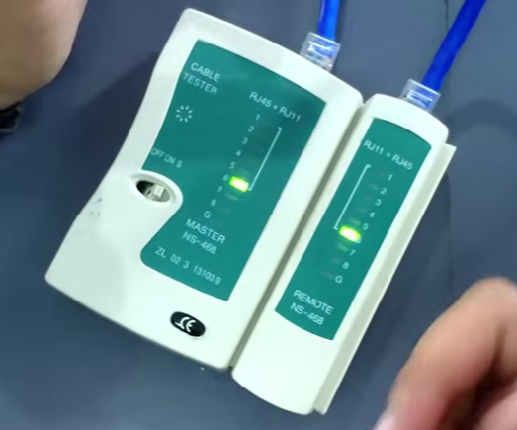

3. TIA/EIA-568B Cable Construction
Because the assigned roll number ends in an odd digit (1), a Straight-Through Ethernet cable was constructed utilising the TIA/EIA-568B standard on both terminations.

Pin | Colour — T568B Pinout Architecture | Colour Swatch
1 | White-Orange
2 | Orange
3 | White-Green
4 | Blue
5 | White-Blue
6 | Green
7 | White-Brown
8 | Brown

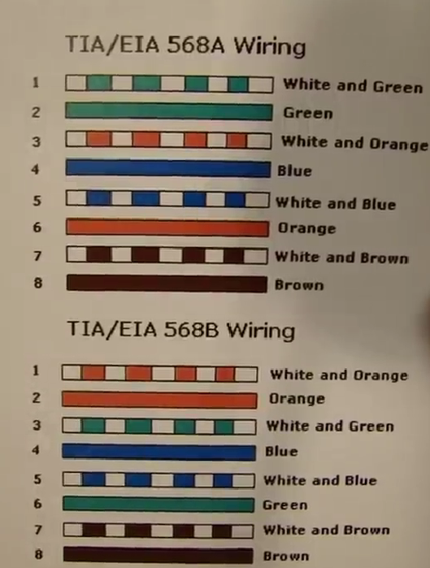
Figure 4: Reference diagram mapping the colour codes for both T568A and T568B standards.

Execution Results
During the physical execution, the outer jacket of the Ethernet cable was stripped using the wire stripper tool. The four internal twisted pairs were carefully separated, untwisted, straightened, and perfectly aligned according to the T568B colour sequence shown above.

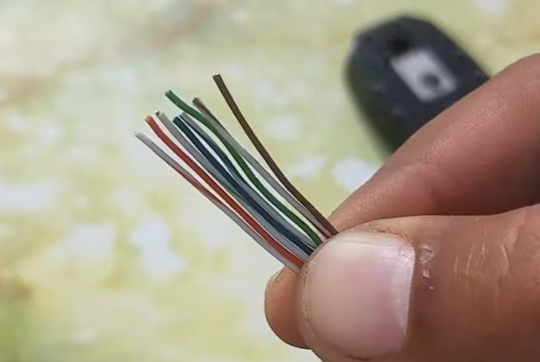
Figure 5: Internal copper wires stripped, untwisted, and aligned left-to-right following the T568B specification.
The aligned wires were then trimmed flush and inserted into the RJ-45 modular plug, ensuring the outer PVC jacket was seated securely inside the connector boot for proper strain relief. The crimping tool was then used to lock the pins into the copper conductors.
Once both ends were securely crimped, the cable was connected to the Master and Remote ports of the LAN cable tester to verify electrical continuity.


Figure 6: Continuity verification demonstrating successful end-to-end signal transmission across all 8 pins.

Execution Summary
Cable Type: Straight-Through (T568B ↔ T568B)
Reason: Roll number ends in odd digit — Straight-Through standard applied.
Stripping Tool: Wire Stripper — outer PVC jacket removed cleanly without conductor damage.
Crimping: RJ-45 pins locked into copper conductors; jacket seated for strain relief.
Verification: LAN Cable Tester confirmed pin-to-pin continuity across all 8 conductors.

